Name: S.ROHITH HT.NO: 2303A52262 B.NO:43

Stack Demonstration
OBSERVATION:A Stack follows the LIFO (Last In, First Out) principle. It is useful for undo operations, recursion handling, and expression evaluation. Key operations include push, pop, peek, and is_empty.
my_stack = Stack()
print(f"Is stack empty initially? {my_stack.is_empty()}")
my_stack.push(10) my_stack.push(20) my_stack.push(30)
print(f"Stack after pushes: {my_stack}") print(f"Peek: {my_stack.peek()}") print(f"Pop: {my_stack.pop()}") print(f"Stack after one pop: {my_stack}") print(f"Is stack empty now? {my_stack.is_empty()}") print(f"Length of stack: {len(my_stack)}") my_stack.pop() my_stack.pop()
print(f"Stack after all pops: {my_stack}") print(f"Is stack empty now? {my_stack.is_empty()}")
try: my_stack.pop() except IndexError as e: print(f"Attempted to pop from empty stack: {e}")
Is stack empty initially? True
Stack after pushes: [10, 20, 30]
Peek: 30
Pop: 30
Stack after one pop: [10, 20]
Is stack empty now? False
Length of stack: 2
Stack after all pops: []
Is stack empty now? True
Attempted to pop from empty stack: pop from empty stack

Queue Demonstration
OBSERVATION: A Queue follows the FIFO (First In, First Out) principle. It is commonly used in scheduling, buffering, and order processing systems. Main operations are enqueue, dequeue, peek, and size
my_queue = Queue()
print(f"Is queue empty initially? {my_queue.is_empty()}") my_queue.enqueue('A') my_queue.enqueue('B') my_queue.enqueue('C')
print(f"Queue after enqueues: {my_queue}") print(f"Peek: {my_queue.peek()}") print(f"Dequeue: {my_queue.dequeue()}") print(f"Queue after one dequeue: {my_queue}") print(f"Is queue empty now? {my_queue.is_empty()}") print(f"Size of queue: {my_queue.size()}") my_queue.dequeue() my_queue.dequeue()
print(f"Queue after all dequeues: {my_queue}") print(f"Is queue empty now? {my_queue.is_empty()}")
try:
my_queue.dequeue() except IndexError as e: print(f"Attempted to dequeue from empty queue: {e}")
Is queue empty initially? True
Queue after enqueues: ['A', 'B', 'C']
Peek: A
Dequeue: A
Queue after one dequeue: ['B', 'C']
Is queue empty now? False
Size of queue: 2
Queue after all dequeues: []
Is queue empty now? True
Attempted to dequeue from empty queue: dequeue from empty queue

Singly Linked List Demonstration
OBSERVATION:A Singly Linked List stores elements dynamically using nodes connected by pointers. It allows efficient insertion without shifting elements. Traversal is required to display or access elements sequentially.
my_linked_list = LinkedList() print("Linked List initially:") my_linked_list.display()
print(f"String representation: '{my_linked_list}'")
my_linked_list.insert(5) my_linked_list.insert(10) my_linked_list.insert(15)
print("Linked List after insertions:") my_linked_list.display()
print(f"String representation: '{my_linked_list}'")
my_linked_list.insert(20)
print("Linked List after another insertion:") my_linked_list.display()
print(f"String representation: '{my_linked_list}'")
Linked List initially:
List is empty
String representation: 'Empty LinkedList'
Linked List after insertions:
15 -> 10 -> 5
String representation: '15 -> 10 -> 5'
Linked List after another insertion:
20 -> 15 -> 10 -> 5
String representation: '20 -> 15 -> 10 -> 5'

Binary Search Tree Demonstration
OBSERVATION:A BST stores data in a sorted hierarchical structure. Left child values are smaller, and right child values are larger than the root. In-order traversal returns elements in sorted order.
bst = BST()
print("Inserting elements into BST...") bst.insert(50) bst.insert(30) bst.insert(70) bst.insert(20) bst.insert(40) bst.insert(60) bst.insert(80)
print(f"In-order traversal of BST: {bst.in_order_traversal()}")
Inserting elements into BST...
In-order traversal of BST: [20, 30, 40, 50, 60, 70, 80]

Hash Table Demonstration
OBSERVATION:A Hash Table stores key-value pairs using a hash function. It provides very fast average-case search, insert, and delete operations. Collisions are handled using chaining.
hash_table = HashTable(capacity=5) # Small capacity to demonstrate collisions
hash_table.insert("apple", 10) hash_table.insert("banana", 20) hash_table.insert("cherry", 30)
hash_table.insert("date", 40) # May collide with apple depending on hash
hash_table.insert("elderberry", 50)
print("\nHash Table content after insertions:") print(hash_table)
print(f"\nSearching for 'banana': {hash_table.search('banana')}") print(f"Searching for 'grape': {hash_table.search('grape')}")
hash_table.delete("cherry") hash_table.delete("fig")
print("\nHash Table content after deletions:") print(hash_table)
Inserted 'apple': '10' at index 0
Inserted 'banana': '20' at index 1
Inserted 'cherry': '30' at index 4
Inserted 'date': '40' at index 2
Inserted 'elderberry': '50' at index 1
Hash Table content after insertions:
Bucket 0: [('apple', 10)]
Bucket 1: [('banana', 20), ('elderberry', 50)]
Bucket 2: [('date', 40)]
Bucket 3: []
Bucket 4: [('cherry', 30)]
Searching for 'banana': 20
Searching for 'grape': None
Deleted 'cherry' from index 4
Key 'fig' not found for deletion.
Hash Table content after deletions:
Bucket 0: [('apple', 10)]
Bucket 1: [('banana', 20), ('elderberry', 50)]
Bucket 2: [('date', 40)]
Bucket 3: []
Bucket 4: []
GRAPH(Adjacency List Implementation)
OBSERVATION:A Graph represents relationships between nodes using edges. An adjacency list efficiently stores sparse graphs. It is widely used in route mapping and network systems.
class Graph: def __init__(self): self.adj_list = {}
def add_vertex(self, vertex):
"""Add a new vertex to the graph."""
if vertex not in self.adj_list: self.adj_list[vertex] = []
def add_edge(self, vertex1, vertex2): """Add an edge between two vertices.""" if vertex1 not in self.adj_list:
self.add_vertex(vertex1) if vertex2 not in self.adj_list: self.add_vertex(vertex2)
self.adj_list[vertex1].append(vertex2)
self.adj_list[vertex2].append(vertex1) # Remove this line for directed graph
def display(self):
"""Display the graph connections.""" for vertex in self.adj_list: print(f"{vertex} -> {self.adj_list[vertex]}")
# Example Usage g = Graph()
g.add_edge("A", "B")
g.add_edge("A", "C")
g.add_edge("B", "D")
g.display()
- -> ['B', 'C']
- -> ['A', 'D']
- -> ['A']
- -> ['B']

- – Priority Queue (Using heapq)
OBSERVATION:A Priority Queue removes elements based on priority, not insertion order. It is commonly implemented using a heap structure. Used in scheduling systems and shortest-path algorithms.
import heapq
class PriorityQueue: def __init__(self): self.queue = []
def enqueue(self, item, priority):
"""Insert item with priority (higher number = higher priority)."""
heapq.heappush(self.queue, (-priority, item)) # negative for max-heap behavior
def dequeue(self):
"""Remove and return highest priority item.""" if not self.is_empty(): return heapq.heappop(self.queue)[1] return None
def display(self):
"""Display queue elements."""
print([item for priority, item in self.queue])
def is_empty(self): return len(self.queue) == 0
# Example Usage pq = PriorityQueue() pq.enqueue("Task1", 2) pq.enqueue("Task2", 5) pq.enqueue("Task3", 1)
pq.display()
print("Dequeued:", pq.dequeue()) pq.display()
['Task2', 'Task1', 'Task3']
Dequeued: Task2
['Task1', 'Task3']

- – Deque (Using collections.deque)
OBSERVATION:A Deque (Double-Ended Queue) allows insertion and deletion from both ends. It combines features of both stack and queue. Useful in sliding window problems and task scheduling.
from collections import deque
class DequeDS: def __init__(self):
"""Initialize an empty double-ended queue.""" self.deque = deque()
def insert_front(self, item):
"""Insert an item at the front.""" self.deque.appendleft(item)
def insert_rear(self, item):
"""Insert an item at the rear.""" self.deque.append(item) def remove_front(self):
"""Remove and return item from the front.""" if not self.is_empty(): return self.deque.popleft() return None
def remove_rear(self):
"""Remove and return item from the rear.""" if not self.is_empty():
return self.deque.pop() return None
def display(self):
"""Display deque elements.""" print(list(self.deque))
def is_empty(self): return len(self.deque) == 0
# Example Usage dq = DequeDS() dq.insert_front(10) dq.insert_rear(20) dq.insert_front(5)
dq.display()
print("Removed from rear:", dq.remove_rear()) dq.display()
[5, 10, 20]
Removed from rear: 20
[5, 10]
- – Campus Resource Management SystemOBSERVATION:
1. Student Attendance Tracking → Deque
A deque allows entry and exit logging from both ends efficiently. It maintains ordered records while supporting flexible insertions.
1. Event Registration System → Hash Table
A hash table enables fast participant search and removal using unique IDs. It provides constanttime average lookup performance.
1. Library Book Borrowing → Binary Search Tree (BST)
A BST keeps books sorted (e.g., by ID or due date). It allows efficient searching and ordered traversal.

class EventRegistration:
"""
Event Registration System using Hash Table (Dictionary). Allows adding, searching, removing, and displaying participants.
"""
def __init__(self): self.participants = {}
def register(self, student_id, name): """Register a student for the event.""" self.participants[student_id] = name
print(f"Student {name} registered successfully.")
def search(self, student_id):
"""Search for a participant by student ID.""" if student_id in self.participants: print(f"Found: {self.participants[student_id]}") else: print("Student not found.")
def remove(self, student_id):
"""Remove a participant from the event.""" if student_id in self.participants: removed = self.participants.pop(student_id) print(f"Removed: {removed}") else: print("Student not found.")
def display(self):
"""Display all registered participants.""" print("\nRegistered Participants:") for sid, name in self.participants.items(): print(f"ID: {sid}, Name: {name}")
# ----------- Main Program ----------event = EventRegistration()
while True: print("\n1. Register Student") print("2. Search Student") print("3. Remove Student") print("4. Display All") print("5. Exit")
choice = input("Enter choice: ")
if choice == "1": sid = input("Enter Student ID: ") name = input("Enter Name: ")
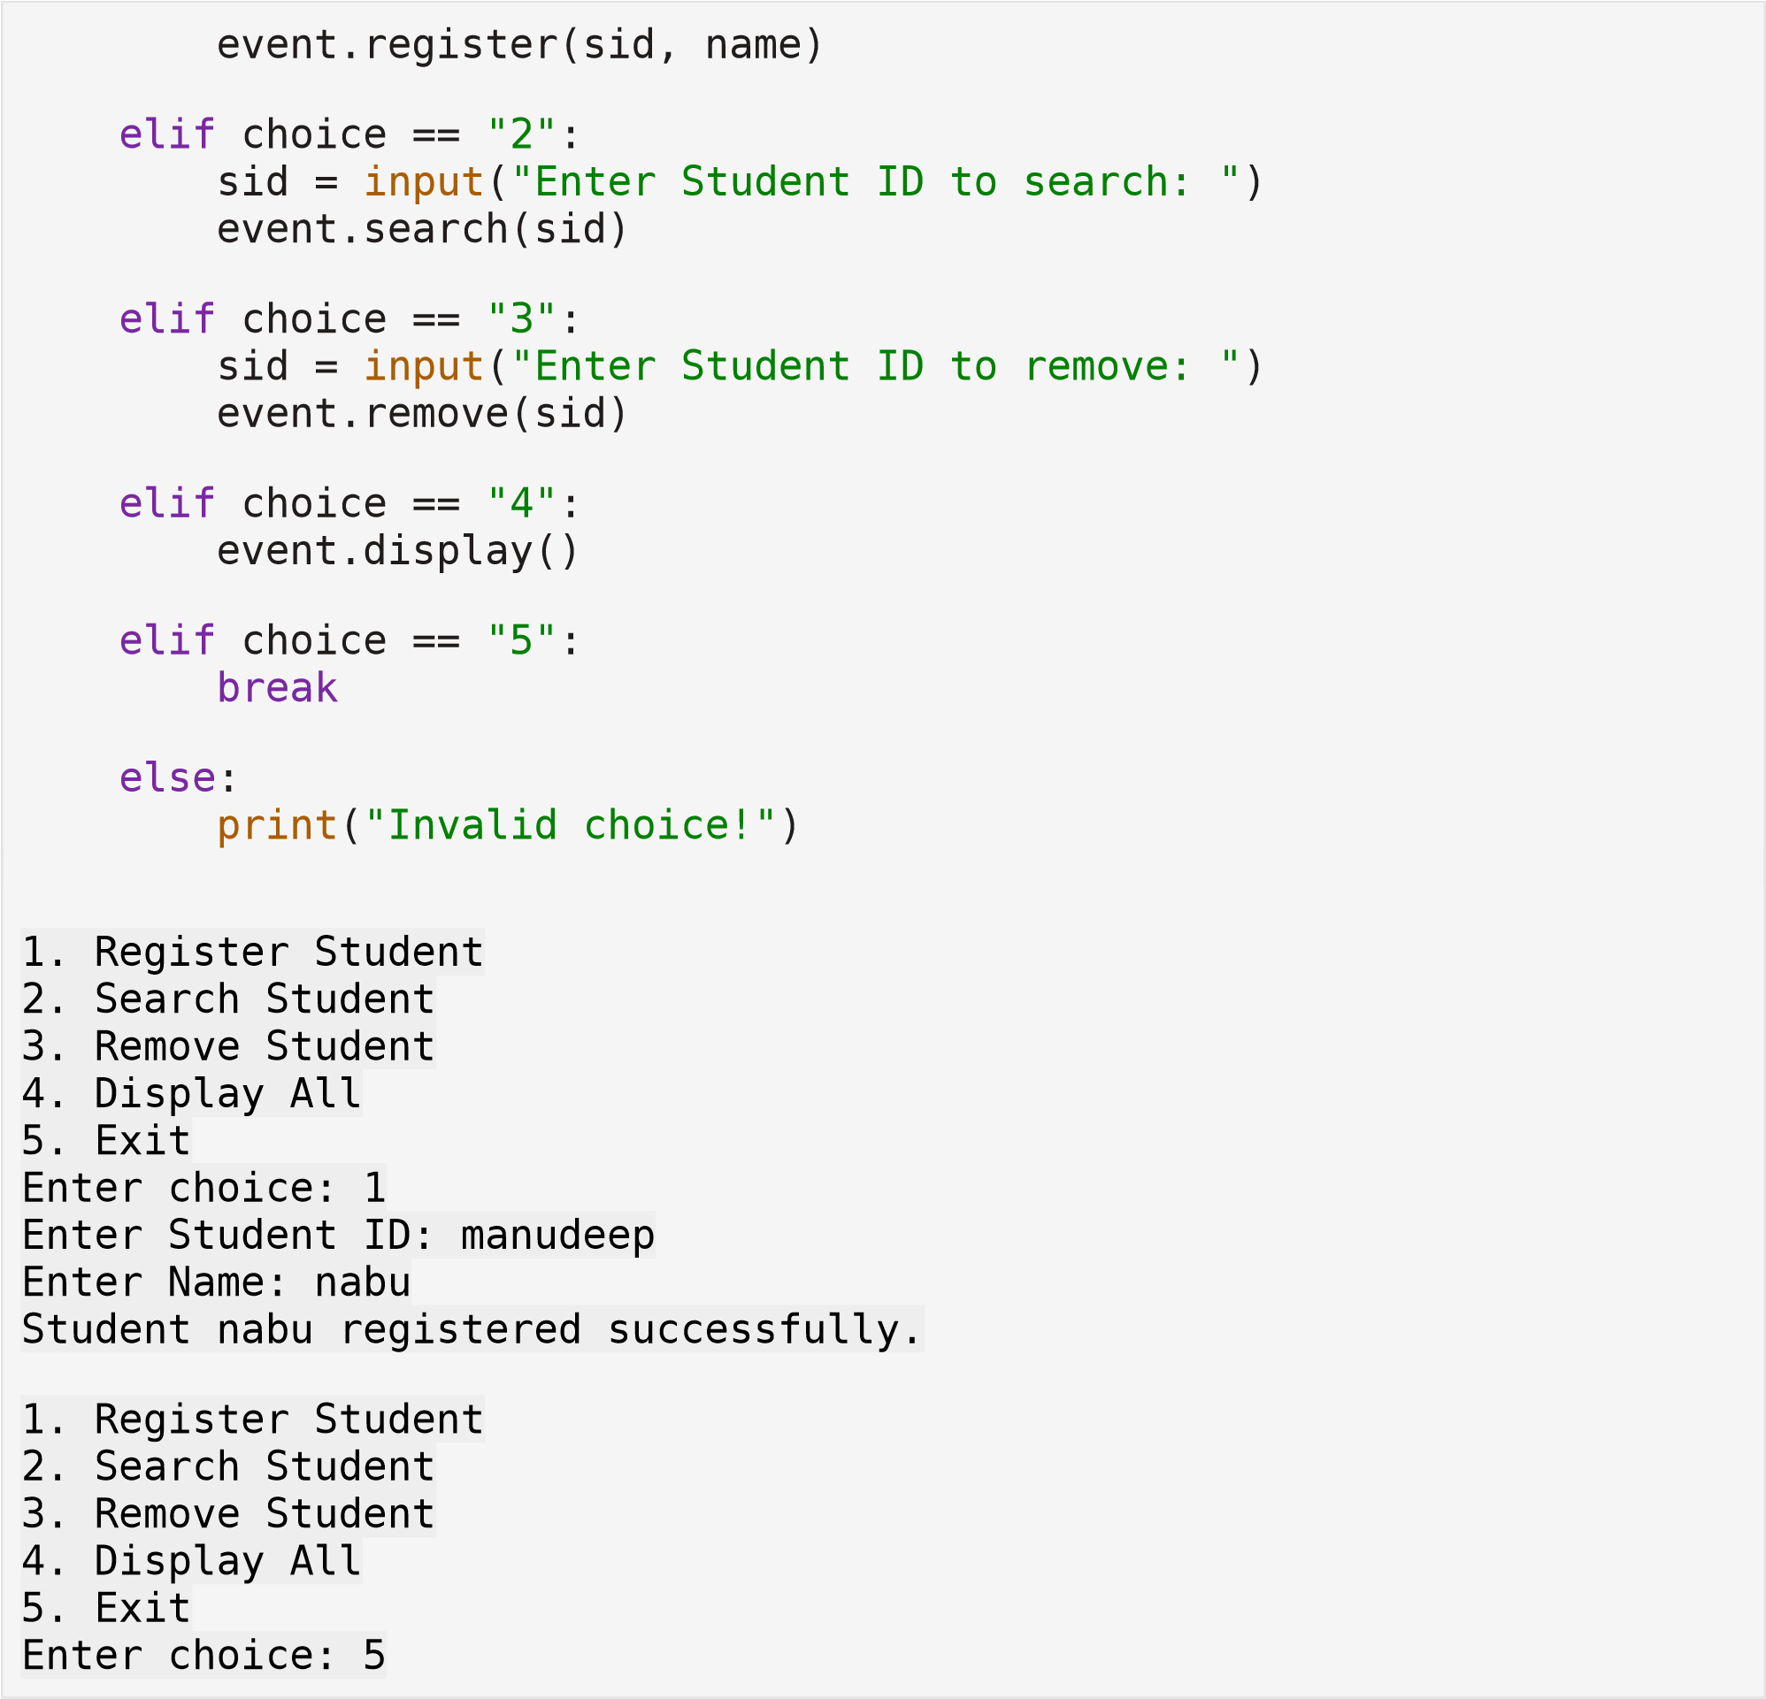
10 – Smart E-Commerce Platform OBSERVATION:
1. Shopping Cart Management → Linked List
A linked list allows dynamic addition and removal of products. It efficiently handles frequent insertions and deletions.
1. Order Processing System → Queue
Orders must be processed in the order placed. A queue ensures FIFO-based handling.
1. Top-Selling Products Tracker → Priority Queue
A priority queue ranks products based on sales count. It efficiently retrieves the highest-selling product.
from collections import deque
class OrderProcessing:
"""
Order Processing System using Queue (FIFO).
Orders are processed in the order they are placed.
"""
def __init__(self): self.orders = deque()
def place_order(self, order_id): """Add order to the queue.""" self.orders.append(order_id)
print(f"Order {order_id} placed successfully.")
def process_order(self):
"""Process the next order.""" if self.orders: order = self.orders.popleft() print(f"Processing Order: {order}") else: print("No orders to process.")
def display_orders(self):
"""Display all pending orders.""" print("\nPending Orders:") for order in self.orders: print(order)
# ----------- Main Program ----------system = OrderProcessing()
while True: print("\n1. Place Order") print("2. Process Order") print("3. Display Pending Orders") print("4. Exit")
choice = input("Enter choice: ")
if choice == "1": oid = input("Enter Order ID: ") system.place_order(oid)
elif choice == "2": system.process_order()

elif
choice
==

"3"
:
system.display_orders()

elif
choice
==

"4"
:

break

else
:

print
(
"Invalid choice!"
)
. Place Orde
r
1
de
. Process Or
2
r
ing Orders
. Display Pend
3
4
. Exi
t
Enter
choice:
1
2

:
Enter Order ID
.
uccessfully
Order 2 placed s
r
. Place Orde
1
. Process Orde
2
r
. Display Pending Orders
3
4
t
. Exi
Enter choice:
4

